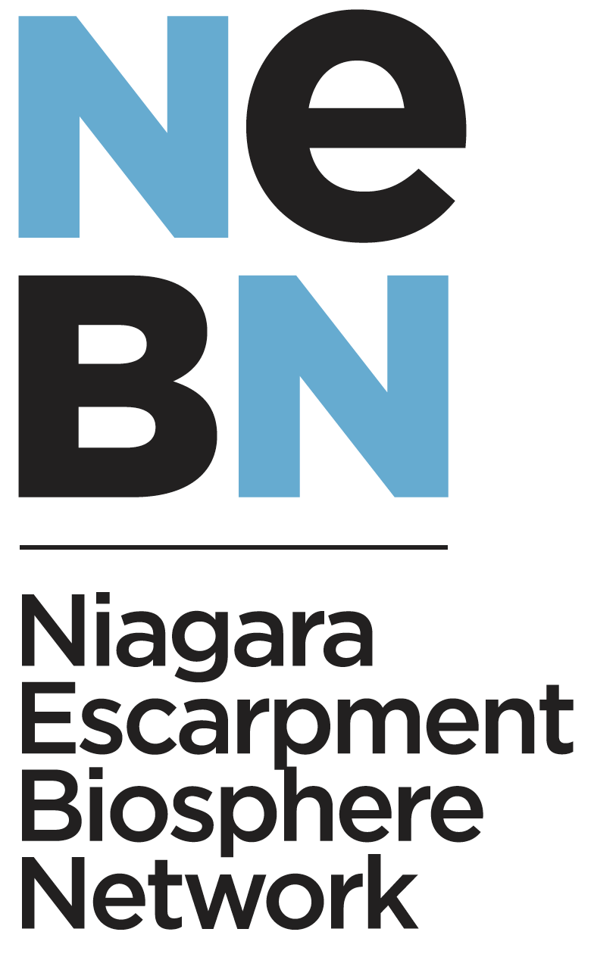

What is the Niagara Escarpment Biosphere?
In recognition of its unique ecological characteristics, the Niagara Escarpment Biosphere (NEB) located in south-central Ontario was designated as United Nations Educational, Scientific and Cultural Organization (UNESCO) World Biosphere in 1990. It is the largest continuous stretch of forested area remaining within Ontario reaching 725 km from Lake Ontario to tip of the Bruce Peninsula. It encompasses two major biomes (Boreal Forest and Temperate Broadleaf Forest), contains 30+ regions/municipalities, and many other diverse natural and urban environments.
The NEB is comprised of three separate zones, including core zones, buffer zones and transitional zones, enveloping approximately 194,555 hectares of land. The unique composition of these three characteristic zones allows for the NEB to conserve biodiversity while simultaneously promoting sustainable development where appropriate. Given the expansive area of the NEB, it is appropriate to accommodate the needs of a number of partners and provide ample opportunity for community engagement. UNESCO does not subscribe to any single model of governance, therefore, governance across the Biosphere’s of different countries varies significantly, depending largely on the objectives and goals of partners and nearby communities.
What is the Niagara Escarpment Biosphere Network?
Following the most recent periodic review of the NEB by UNESCO, fundamental changes were required to maintain the critical UNESCO Biosphere Designation. A key recommendation was how the NEB was governed and how it engaged with partners - especially Indigenous Peoples. To guide a governance transition, a Transition Leadership Committee (TLC) was established to facilitate the transition.
The NEB has transitioned from a government oversight model to a citizen-led model, including emphasis on meaningful Indigenous engagement and partnership. In fact, TLC is in a co-management framework with Plenty Canada, an Indigenous led organization working to share resources with Indigenous Peoples and community groups around the world in support of environmental sustainability. The Niagara Escarpment Biosphere Transitional Leadership Committee has been working to establish the Niagara Escarpment Biosphere Network (NEBN) as the new entity that will focus on maintaining the biosphere designation in partnership with all communities within the NEB. In March 2022, the NEBN became officially incorporated under provincial regulations.
What is the difference between the Niagara Escarpment Commission and the Niagara Escarpment Biosphere Network?
The Niagara Escarpment Commission (NEC) is a provincially legislated body with a responsibility that focuses on its land use mandate under the Niagara Escarpment Planning and Development Act, guided by the Niagara Escarpment Plan. Ensuring compliance with its regulatory land use policies is an important function of the NEC.
The goal of a UNESCO Biosphere is to promote biodiversity, conservation and relationships between humans and the environment. A recent UNESCO review of the NEB noted a need to better measure conservation, biodiversity, and human relation impacts, not just compliance. This includes promoting biodiversity not only within the NEB but also on adjacent lands. Although this work has been on-going by community groups for many years across the Niagara Escarpment, it has not been captured and networked in a way that provides meaningful inputs into the NEB.
The NEBN is a separate, provincially incorporated entity that will address the missing pieces of the UNESCO designation that includes measuring impacts on the biodiversity of the NEB. The NEBN is a community-led organization that includes partners within the NEB - including an important co-governance model with Indigenous Peoples.
Why your support is important to the NEBN?
To continue to maintain the important Niagara Escarpment Biosphere designation from UNECSO, the NEBN needs the support of First Nations, elected officials, community leaders, educational institutions, environmental groups, business organizations - in essence all groups that see the importance of the Niagara Escarpment as it has been protected for generations.
Through resolutions, stories, letters, and testimonials, the NEBN needs to verify to UNESCO that there is a strong and unified, cross-societal base of support for the continuation of the NEB. Additionally, it is important for UNESCO to see the widespread support for the NEBN as the networking agency that connects the Niagara Escarpment in a way that celebrates all of its benefits – environmental, cultural, economic, and social – with our communities.

